# **Types of Attention -Bahdanau Attention Vs Luong Attention**

Here are notes on the concepts discussed in the source regarding Bahdanau and Luong Attention, along with some additional points to enhance understanding:

**RECAP of ENCODER-Decoder and Attention**

**1. The Problem: Neural Machine Translation (NMT)**

* The problem statement involves translating a sentence from one language (e.g., English: "Turn off the lights") to another (e.g., Hindi: "लाइट बंद करो") using deep learning neural networks.
* This problem is known as Neural Machine Translation (NMT) in deep learning.
* Historically, machine translation was attempted using various methods, but deep learning brought new neural network architectures to solve this problem.

**2. Initial Approach: Encoder-Decoder Architecture**

* The first architecture tried for NMT was an Encoder-Decoder architecture.
* This architecture consists of two separate blocks: an encoder and a decoder.
* Both the encoder and decoder typically contain an LSTM (or bi-LSTM, stacked LSTM).
* The encoder processes the input sentence word by word. For "Turn off the lights," it would process "Turn," then "off," then "the," then "lights".
* The encoder's task is to prepare a summary or a representation of the input sentence, which is called a context vector in deep learning.
* The encoder generates a single context vector that is passed to the decoder.
* The decoder's job is to step by step print the output translation using this context vector. For "लाइट बंद करो," it would print "लाइट," then "बंद," then "करो," and then "end".
* In summary, the encoder encodes/summarises the input sentence and sends this summary (context vector) to the decoder, which uses it to generate the output sentence step by step.

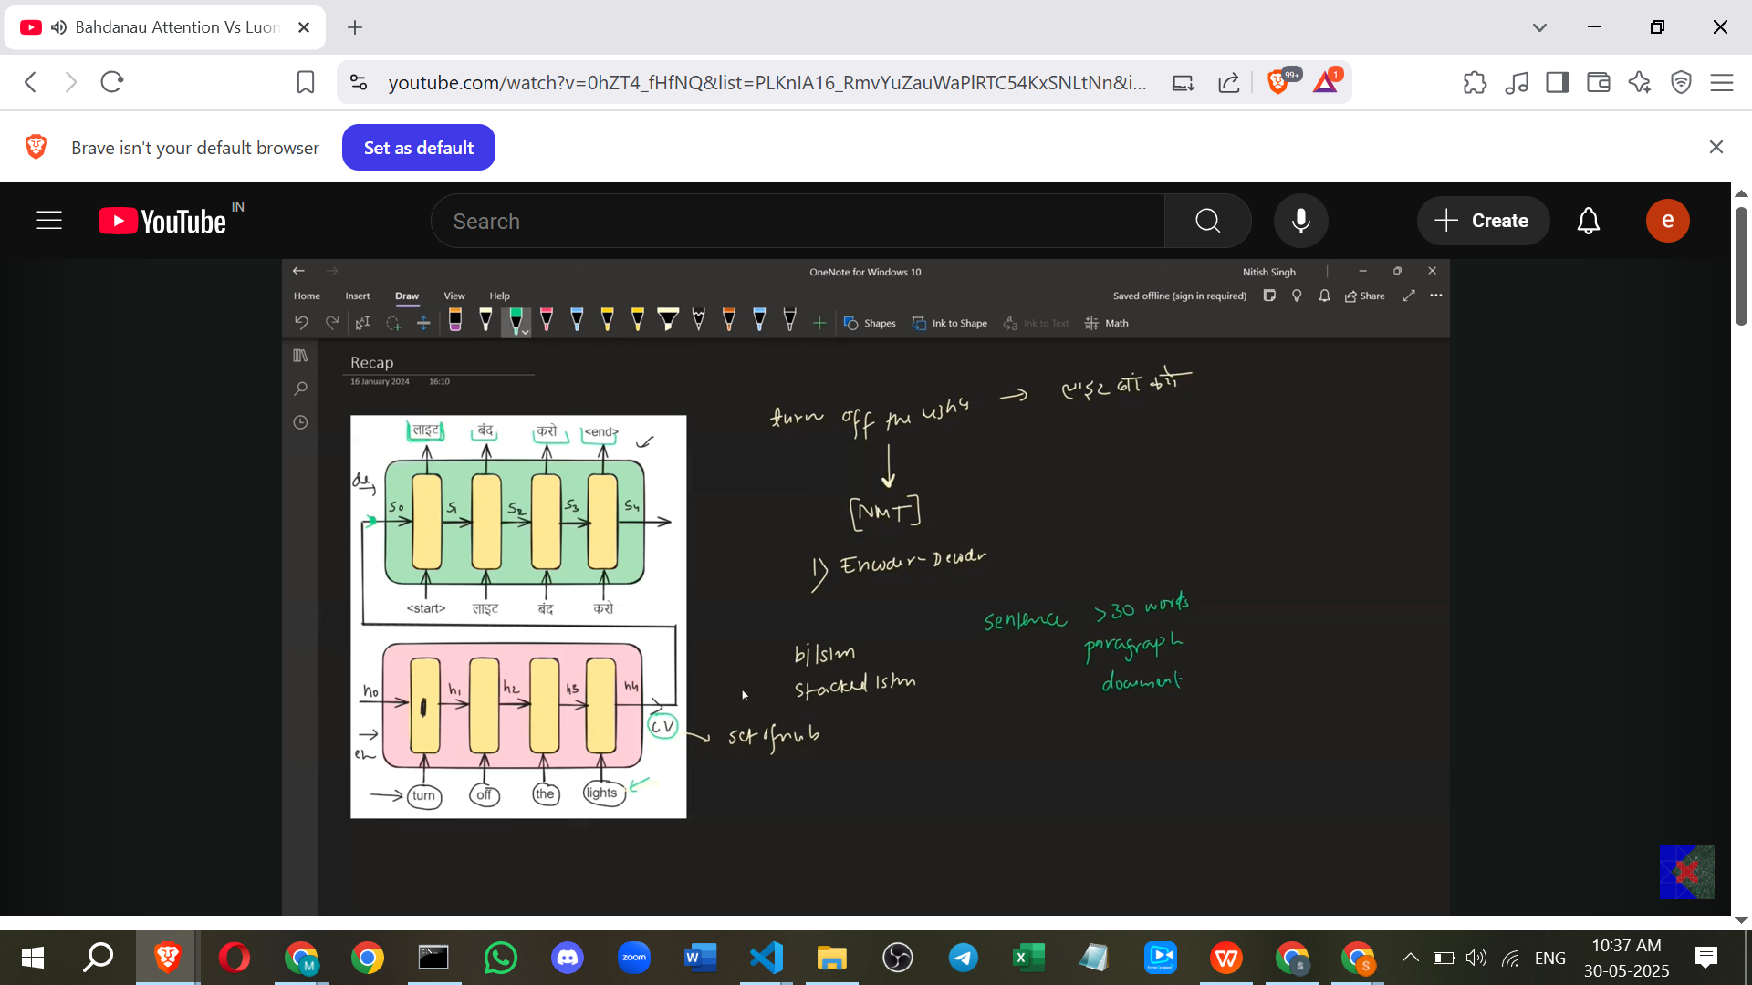

**3. Limitation of the Basic Encoder-Decoder**

* The main problem with this approach arises when using longer sentences, such as those greater than 30 words, paragraphs, or even entire documents.
* The encoder struggles to convert the entire long input into a single context vector because a single set of numbers (the context vector) can only store so much representation or summary.
* Since the context vector is not generated correctly for long inputs, the decoder also fails to generate the correct output words.
* Empirical observations showed that for sentences longer than 30 words, the quality of the translation was not very good. This became a significant bottleneck.

**4. The Solution: Attention Mechanism**

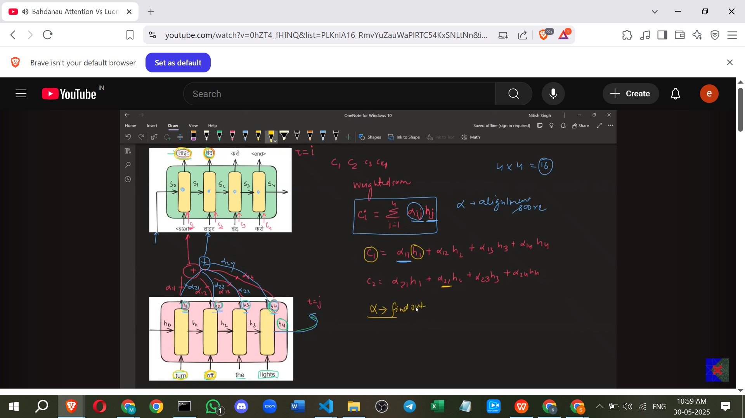

* To eliminate the bottleneck of the single context vector, a new mechanism called the Attention Mechanism was introduced.
* The core idea of attention is that when the decoder is at a particular time step (e.g., trying to print "लाइट"), it doesn't need the entire input sentence summary.
* Instead, it only needs specific words or a subset of words from the input that are relevant to the current output word. For example, to print "लाइट," the word "lights" might be needed. To print "बंद," the words "Turn" and "off" might be relevant.
* The Attention Mechanism discards the concept of sending only the final hidden state (e.g., h4) as the context vector.
* Instead, it makes all the intermediate encoder hidden states (h1, h2, h3, h4 in the example) available at every time step of the decoder.
* At any time step, the decoder can dynamically select and use specific encoder hidden states that are most relevant.
* This selection process involves sending a context vector (c1, c2, c3, c4 for each decoder step) at every time step of the decoder, rather than just once at the beginning.

**5. Calculating the Context Vector (c_i) using Attention**

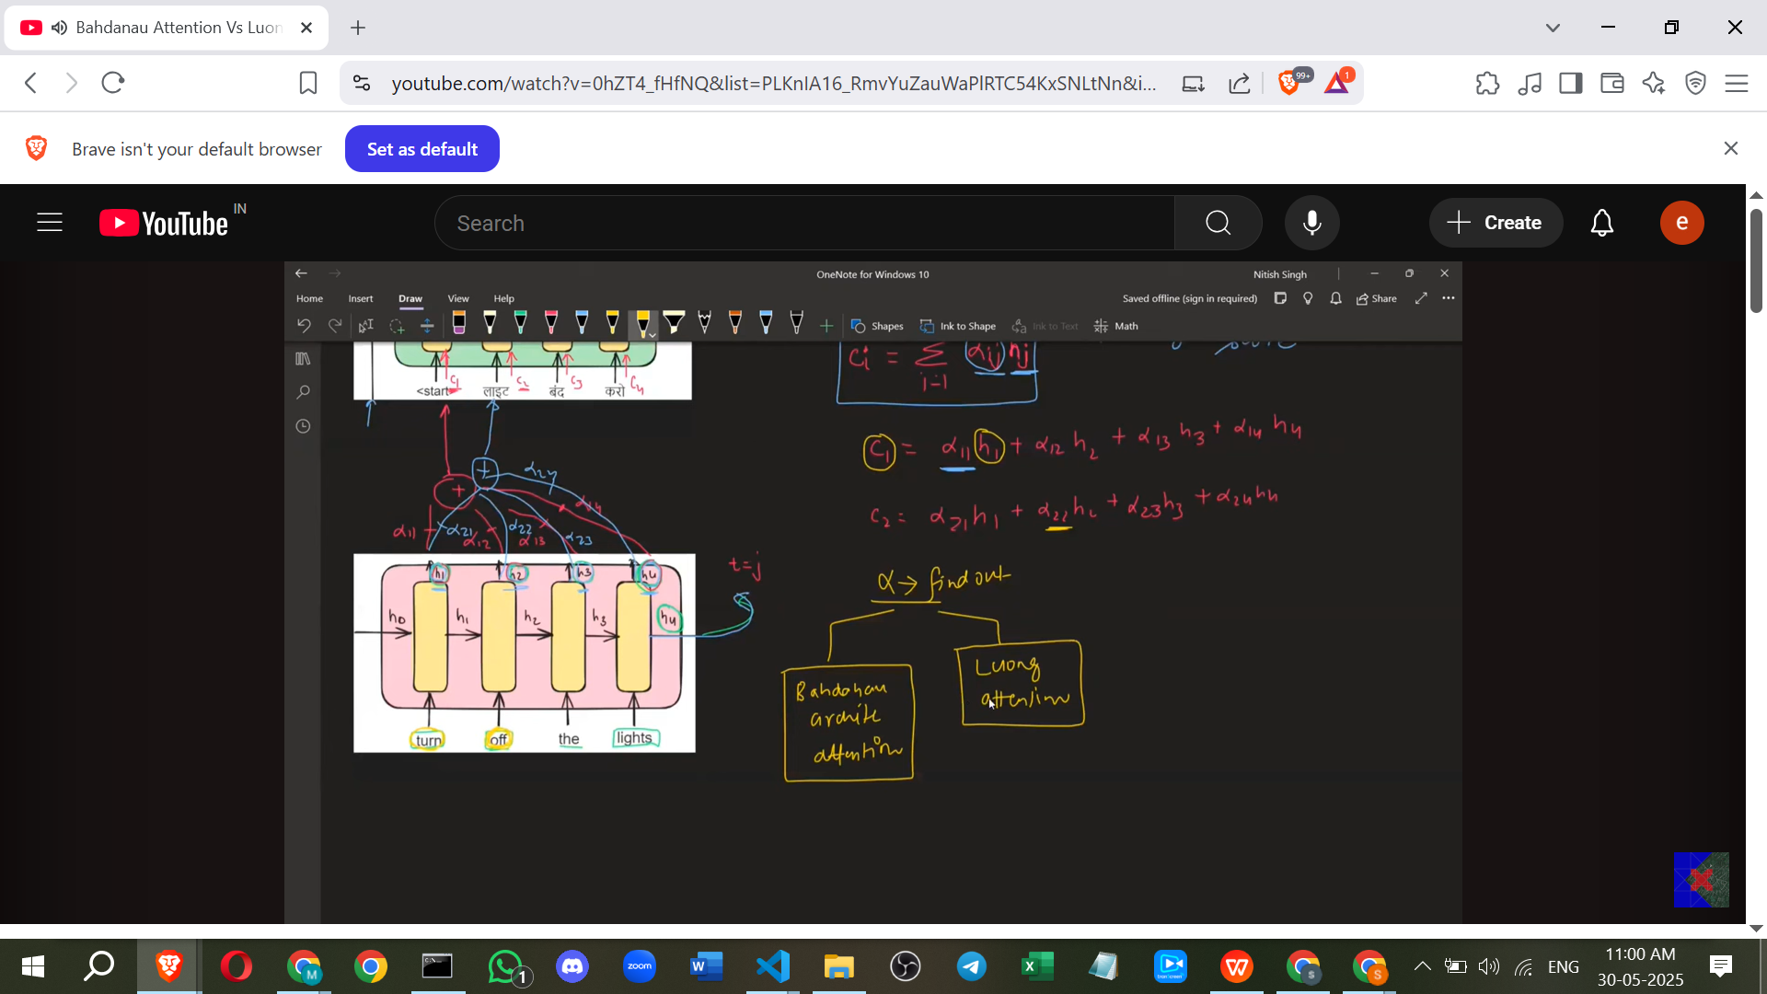

* The context vector c_i at decoder time step i is calculated as a **weighted sum** of the encoder hidden states h_j.
* The formula is: c_i = Σ (Alpha_ij * h_j).
* Here, Alpha_ij are the **weights**. These weights are also called **alignment scores** in literature.
* The main challenge is to figure out how to find these alpha (Alpha_ij) values.
* The alpha_ij scores represent the strength of the relationship or the importance of encoder hidden state h_j for generating the output at decoder time step i. For example, Alpha_11 indicates the importance of the word "Turn" (associated with h1) for printing "लाइट" (at decoder step 1). Alpha_21 indicates the importance of "Turn" (h1) for printing "बंद" (at decoder step 2).
* These alphas are essentially word-to-word similarity scores.

**6. Bahdanau Attention (Additive Attention)**

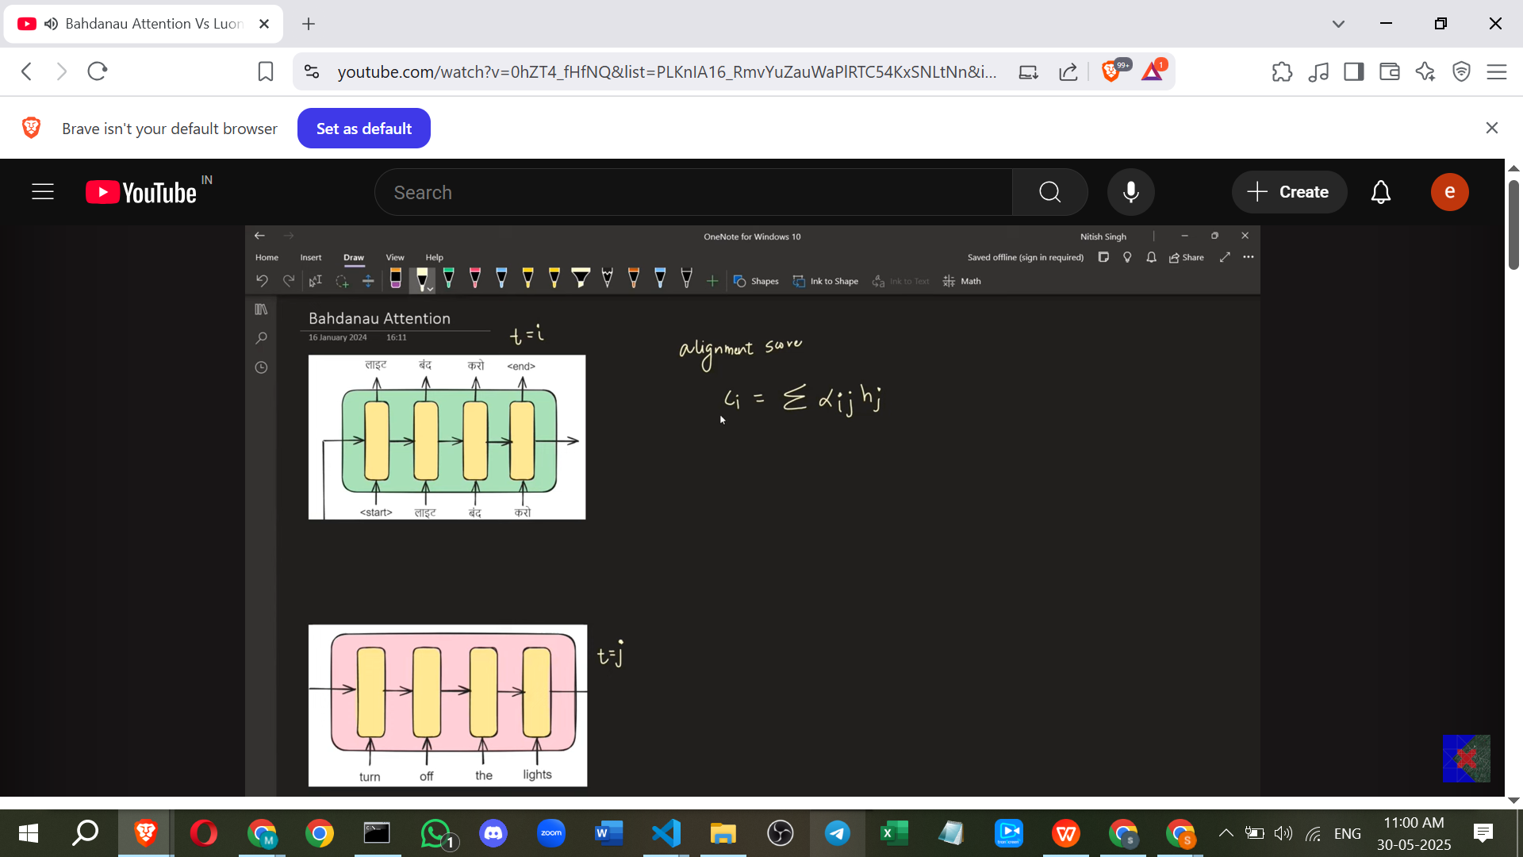

* Bahdanau Attention is one method to calculate the alpha (alignment) scores. It is also known as **Additive Attention**.
* In Bahdanau Attention, the alignment score (Alpha_ij) is a function of **two things**:
  + The **encoder hidden state** h_j.
  + The **previous decoder hidden state** s_i-1.
* The reason for using the previous decoder hidden state (s_i-1) is that the contribution of an input word (h_j) to the current output word depends on the context of what has already been translated (which is stored in the previous decoder hidden state).

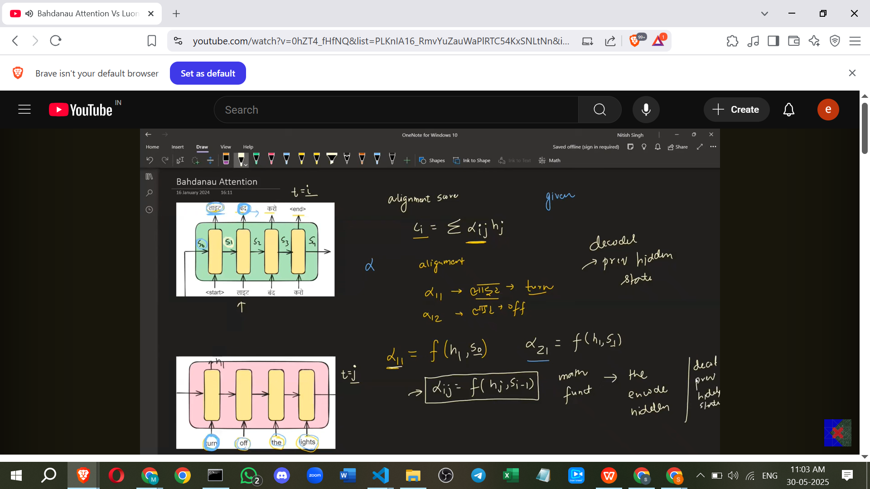

* Bahdanau Attention approximates the mathematical function that calculates the alignment scores using a **feed-forward neural network (FFNN)**.
* This FFNN is sometimes called the **alignment model**.

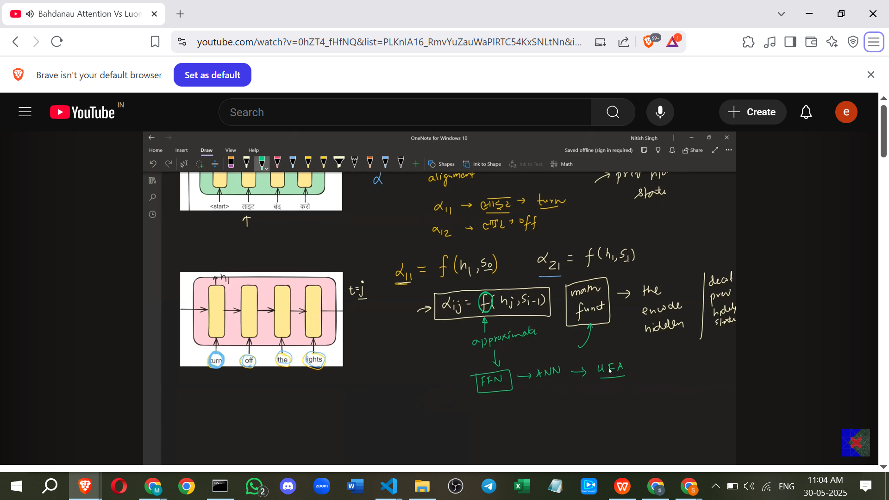

* The FFNN takes the concatenated previous decoder hidden state (s_i-1) and encoder hidden state (h_j) as input.
* The output of this FFNN is a score, let's call it e_ij.
* To get the final Alpha_ij values, a **softmax** function is applied over the e_ij scores corresponding to a particular decoder step i across all encoder states j. Softmax normalises the scores, making them positive and sum up to 1.

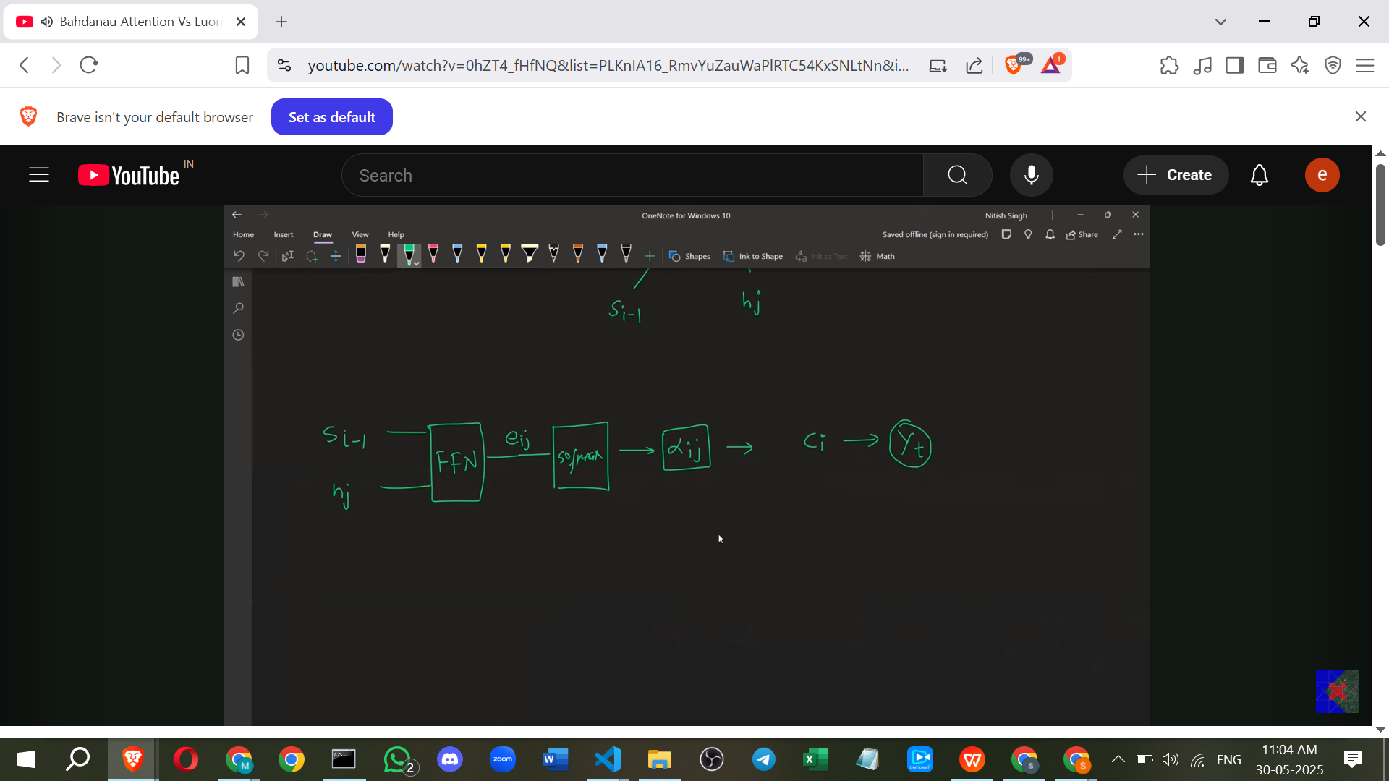

* **Architectural Flow (Bahdanau):**

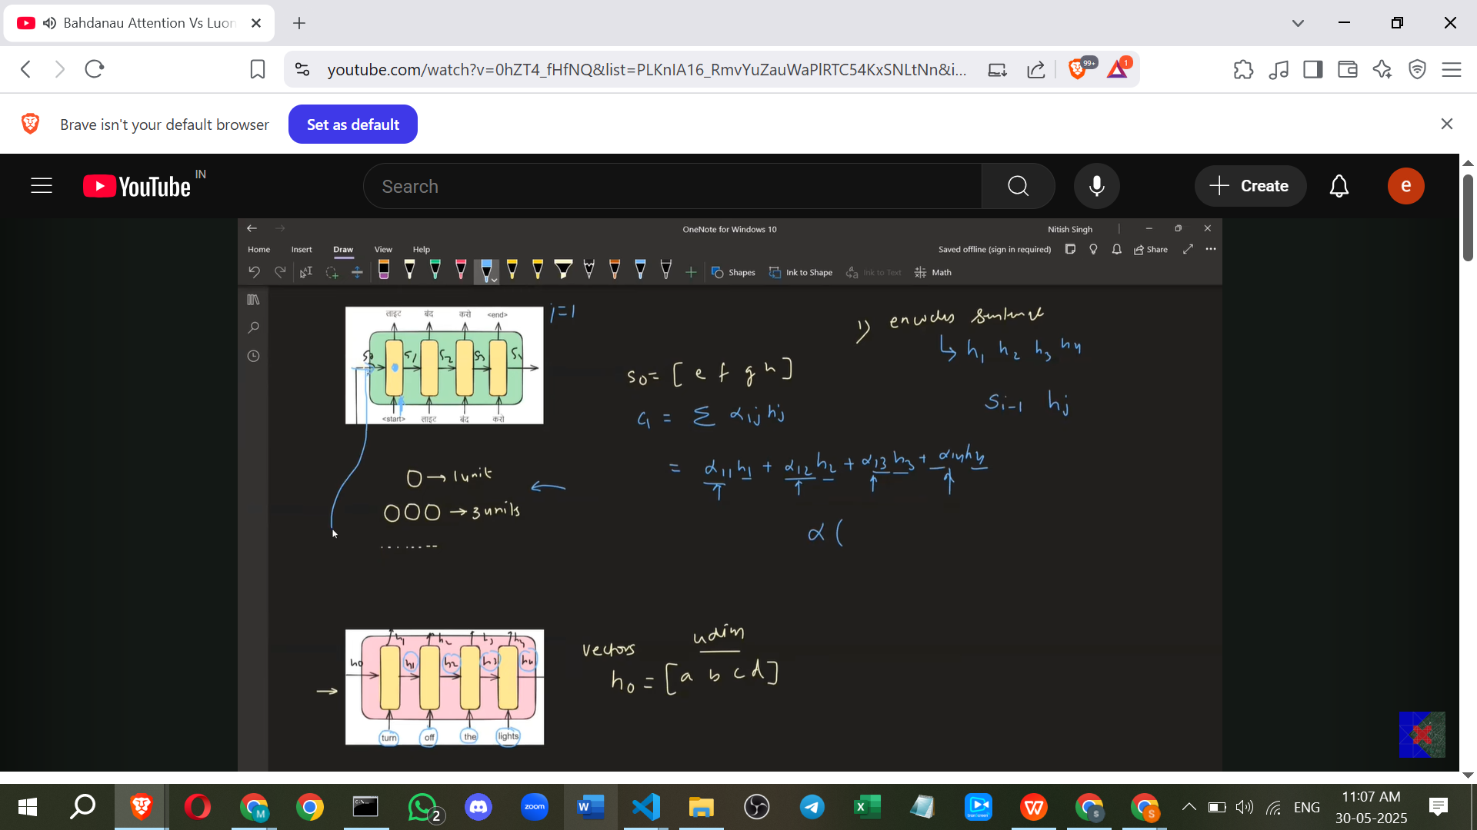

* + Encoder computes all h_j states.
  + For the first decoder step (i=1), the previous decoder state is s0 (initial state or last encoder state h4).
  + s0 is concatenated with each h_j (h1, h2, h3, h4) to form input pairs (s0||h1, s0||h2, s0||h3, s0||h4).

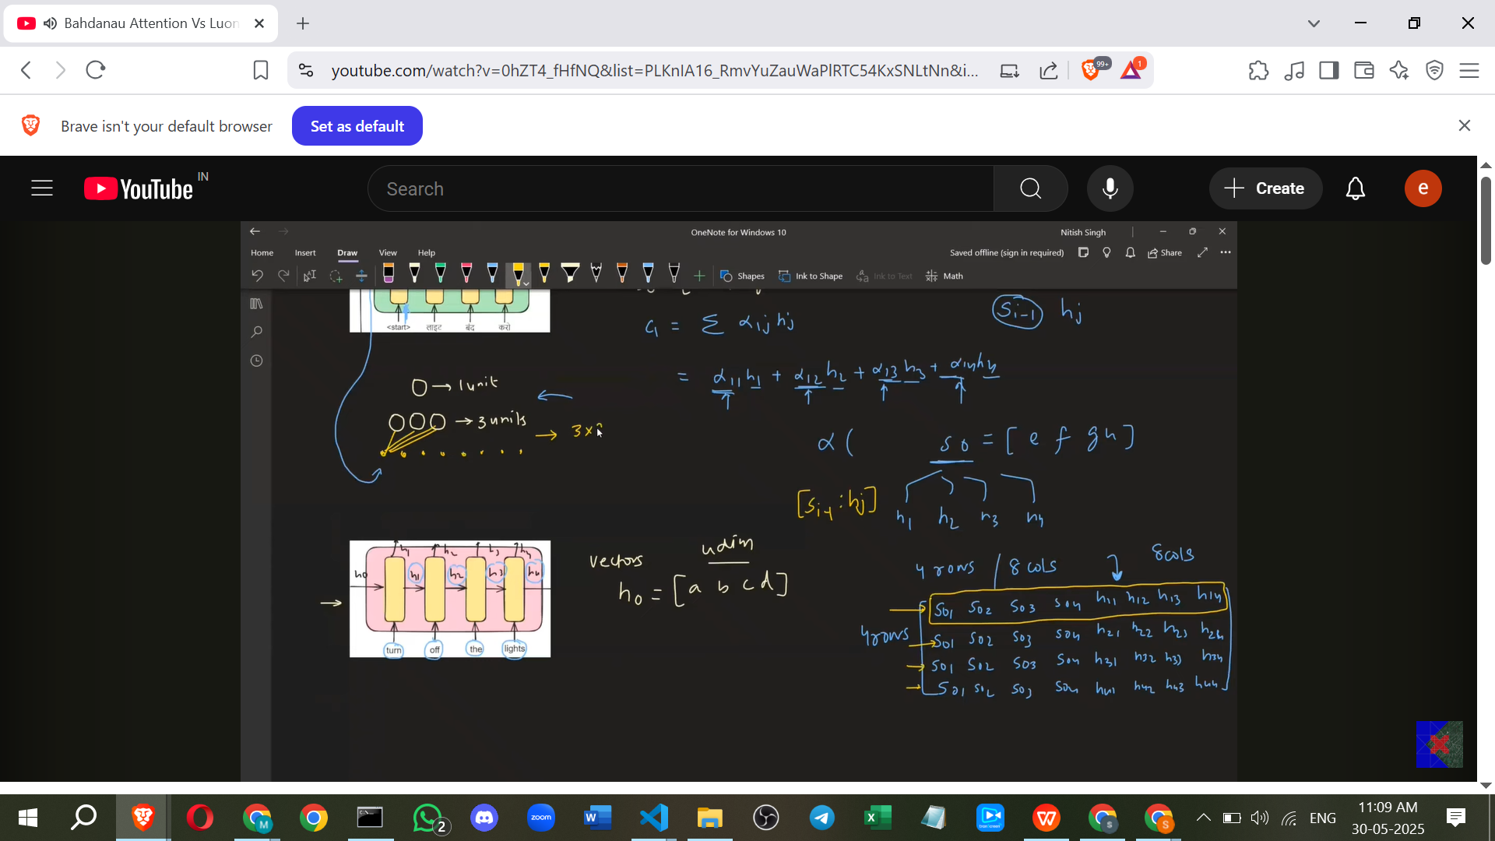

* + These concatenated pairs are fed into the FFNN (alignment model). This can be done as a batch operation.
  + The FFNN outputs the e_1j scores (e11, e12, e13, e14).

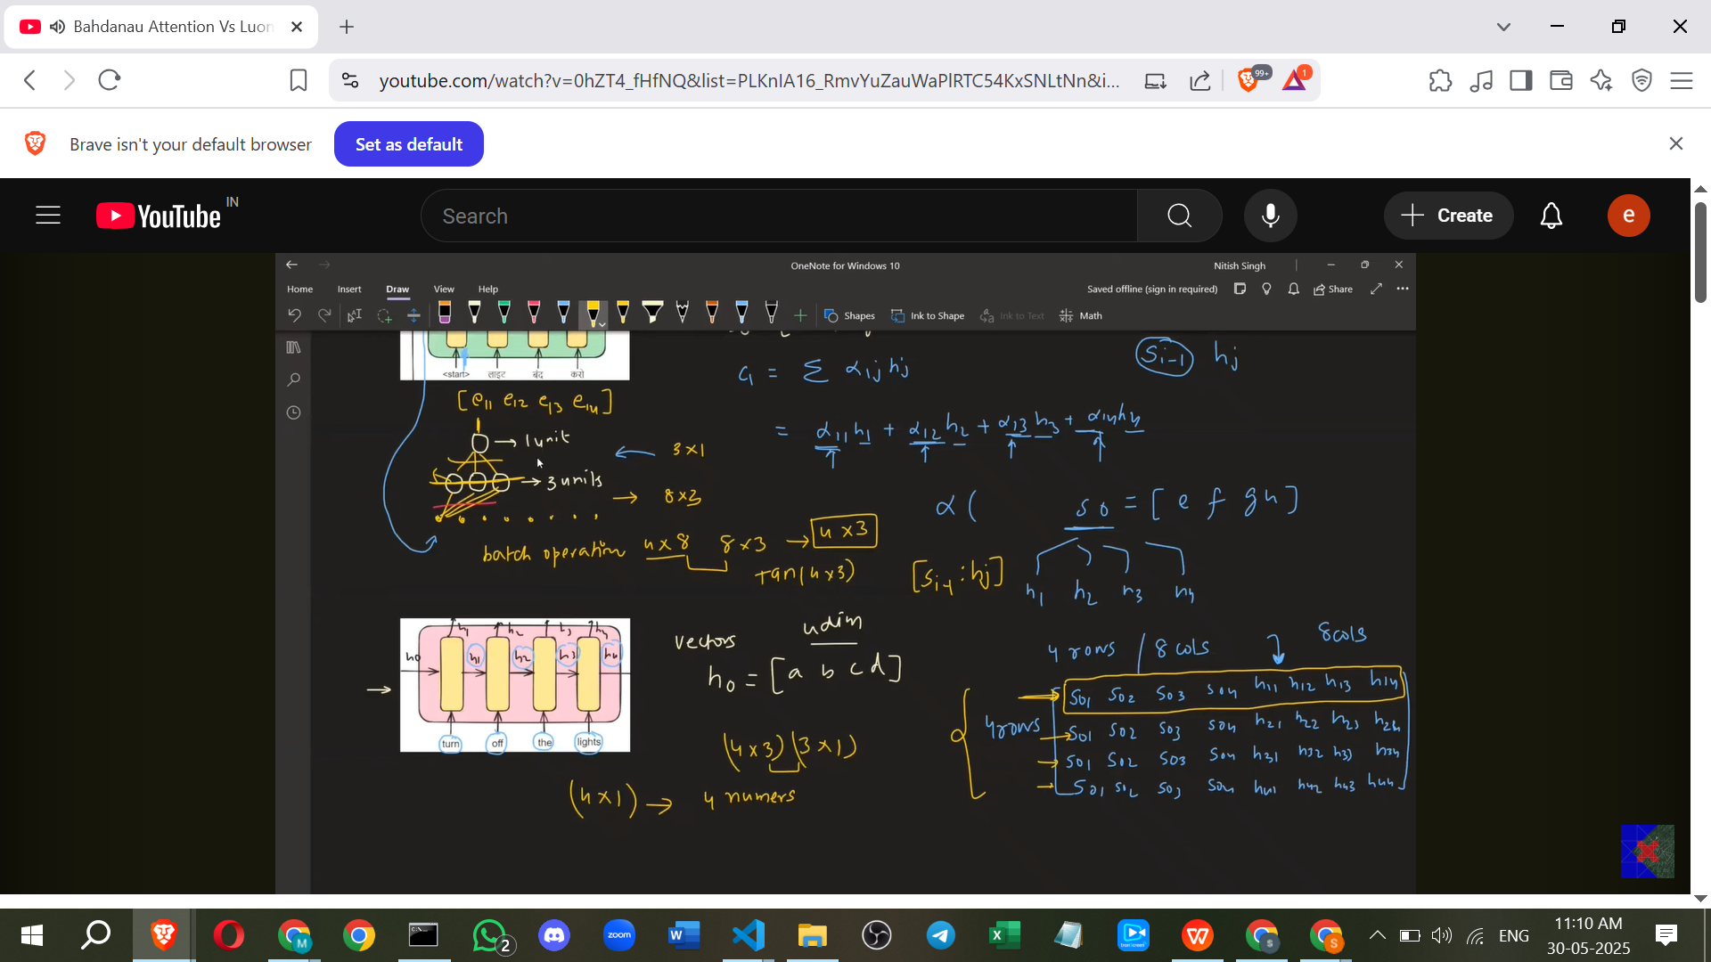

* + Softmax is applied to the e_1j scores to get Alpha_1j (Alpha_11, Alpha_12, Alpha_13, Alpha_14).
  + The context vector c1 is calculated as the weighted sum: c1 = Alpha_11*h1 + Alpha_12*h2 + Alpha_13*h3 + Alpha_14*h4.
  + c1, the input word (y_t-1, e.g., START token), and the previous decoder state (s0) are fed into the decoder LSTM to produce the output word (y_t, e.g., "लाइट") and the next decoder state (s1).
  + This proces**s repeats for the next decoder step (i=2),** but this time using s1 as the previous decoder state (s1||h1, s1||h2, etc.) to calculate Alpha_2j, c2, and then the next output word ("बंद") and s2.

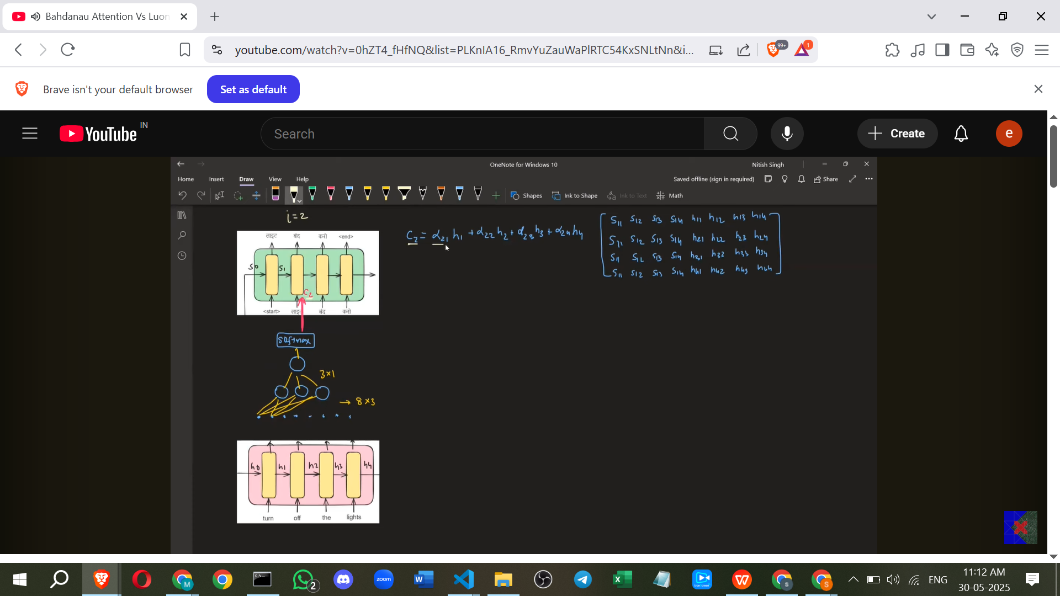

* + The weights of the FFNN (alignment model) are shared across all decoder time steps (**Time-Distributed FFNN**). These weights are updated during backpropagation when the decoder finishes generating the output sequence.

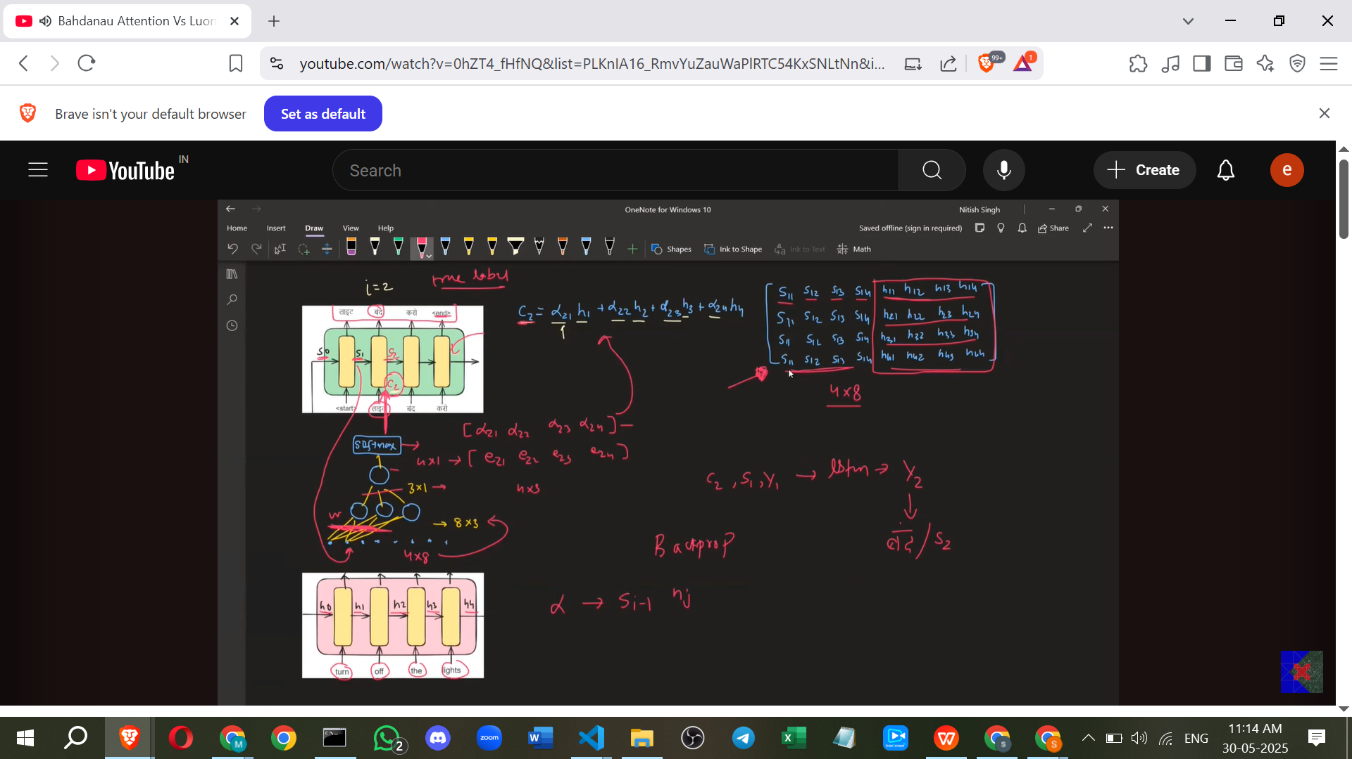

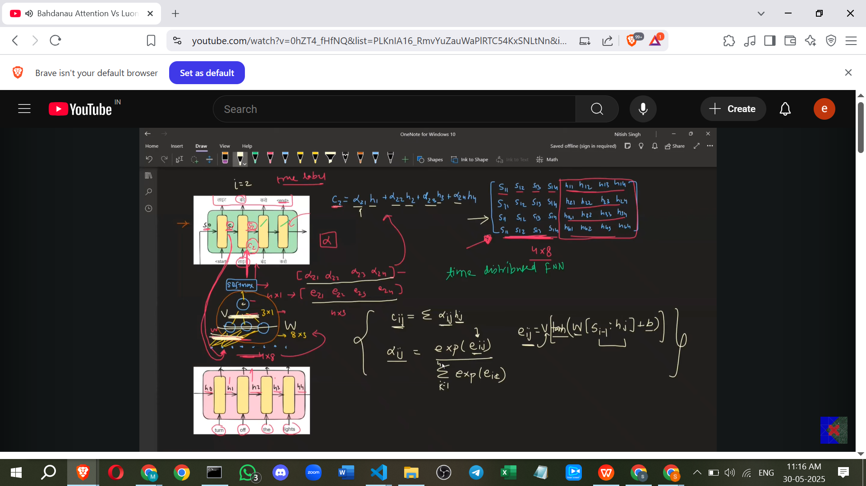

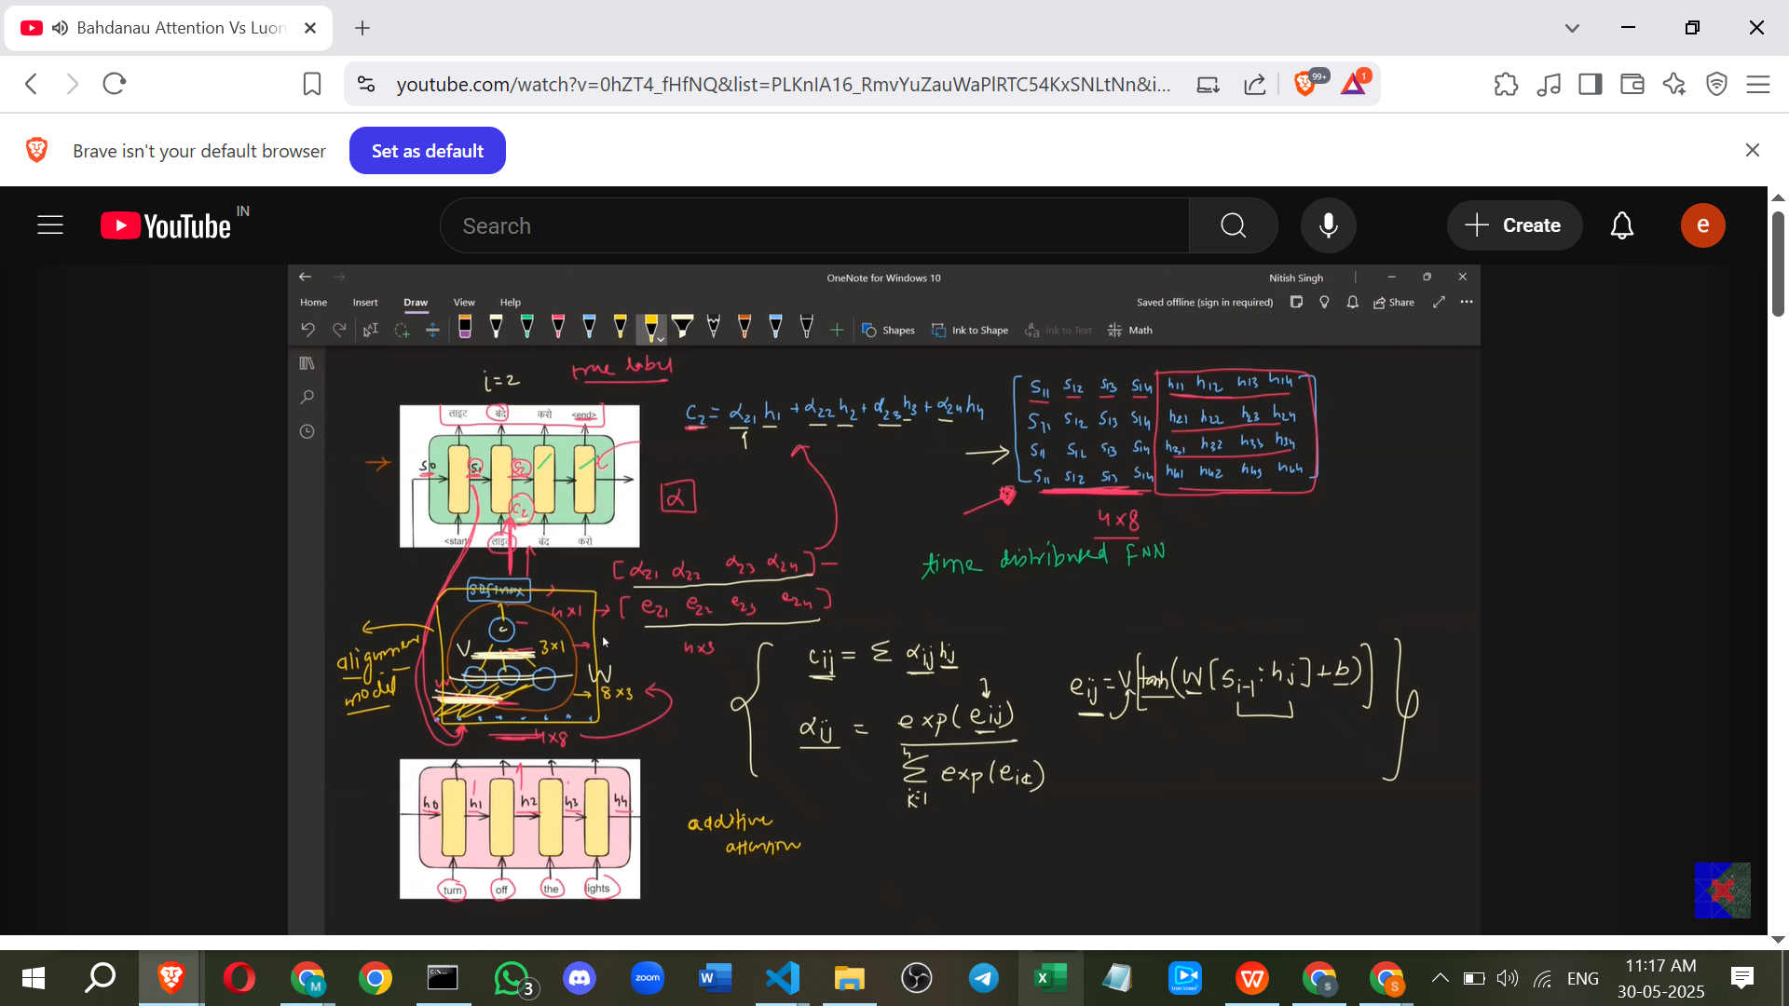

**7. Luong Attention (Multiplicative Attention)**

* Luong Attention was developed after Bahdanau Attention and introduced some improvements. It is also known as **Multiplicative Attention**.
* Luong Attention also calculates attention scores (alphas).
* However, in Luong Attention, the alignment score (Alpha_ij) is a function of the **current decoder hidden state** s_i and the encoder hidden state h_j. This is the **first key difference** from Bahdanau, which uses s_i-1. Using the current state provides more updated information for calculating relevance.

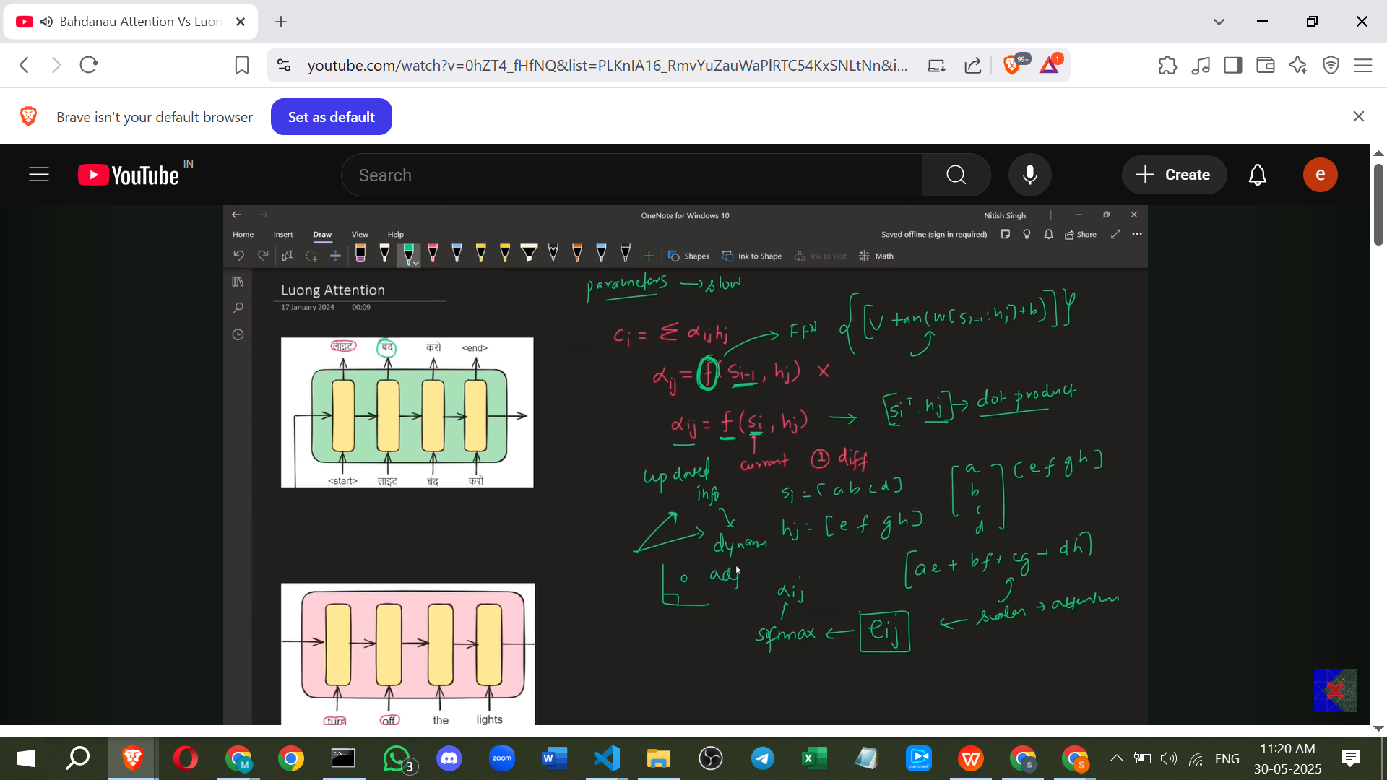

* Luong Attention uses a **simpler function** to calculate the alignment scores (e_ij) instead of a neural network. The most common method is the **dot product** between the current decoder state (s_i) and the encoder state (h_j). This is the **second key difference**.
* The dot product measures similarity between vectors; similar vectors have a higher dot product. This serves the purpose of finding relevant encoder states without adding extra parameters of a neural network.
* The e_ij is simply s_i ⋅ h_j.
* As with Bahdanau, a **softmax** function is applied to the e_ij scores to get the Alpha_ij values.
* The context vector c_i is still calculated as the weighted sum: c_i = Σ (Alpha_ij * h_j).
* The **third key difference** in Luong Attention lies in how the context vector (c_i) is used in the decoder.



* **Architectural Flow (Luong):**

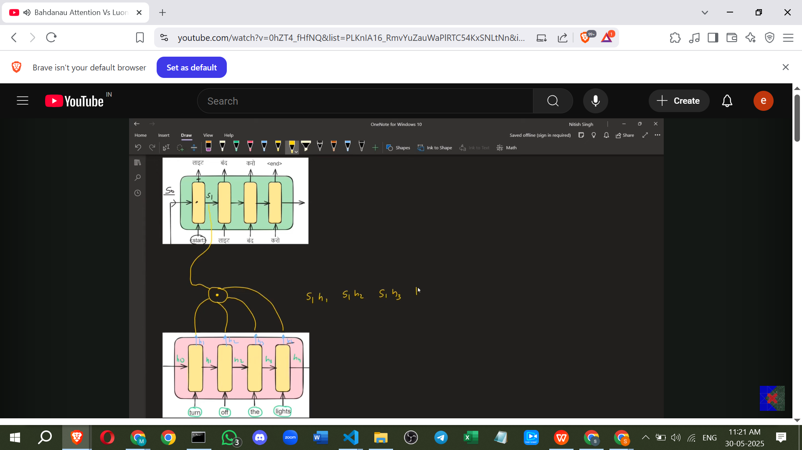

* + Encoder computes all h_j states.
  + For the first decoder step, the decoder LSTM takes the previous decoder state (s0, e.g., initialized) and the input word (y_t-1, e.g., START token) and calculates the **current decoder state (s1)** first.
  + This current decoder state s1 is then used to calculate the alignment scores with each encoder state h_j.
  + e_1j = s1 ⋅ h_j (s1⋅h1, s1⋅h2, s1⋅h3, s1⋅h4).
  + Softmax is applied to the e_1j scores to get Alpha_1j.
  + The context vector c1 is calculated as the weighted sum: c1 = Alpha_11*h1 + Alpha_12*h2 + Alpha_13*h3 + Alpha_14*h4.
  + Crucially, this context vector c1 is **not** fed back into the LSTM as input. Instead, it is **concatenated** with the **current decoder state (s1)** *after* the LSTM step.
  + This concatenated state (s1||c1) is then fed into a feed-forward network (usually just one layer) followed by a softmax to produce the output word (y_t, e.g., "लाइट").
  + The process repeats for the next step: the LSTM takes s1 and y_t (e.g., "लाइट") to calculate s2. s2 is dotted with all h_j to get e_2j, softmax gives Alpha_2j, weighted sum gives c2. c2 is concatenated with s2 (s2||c2) and fed into the output layer FFNN to get the next word ("बंद").

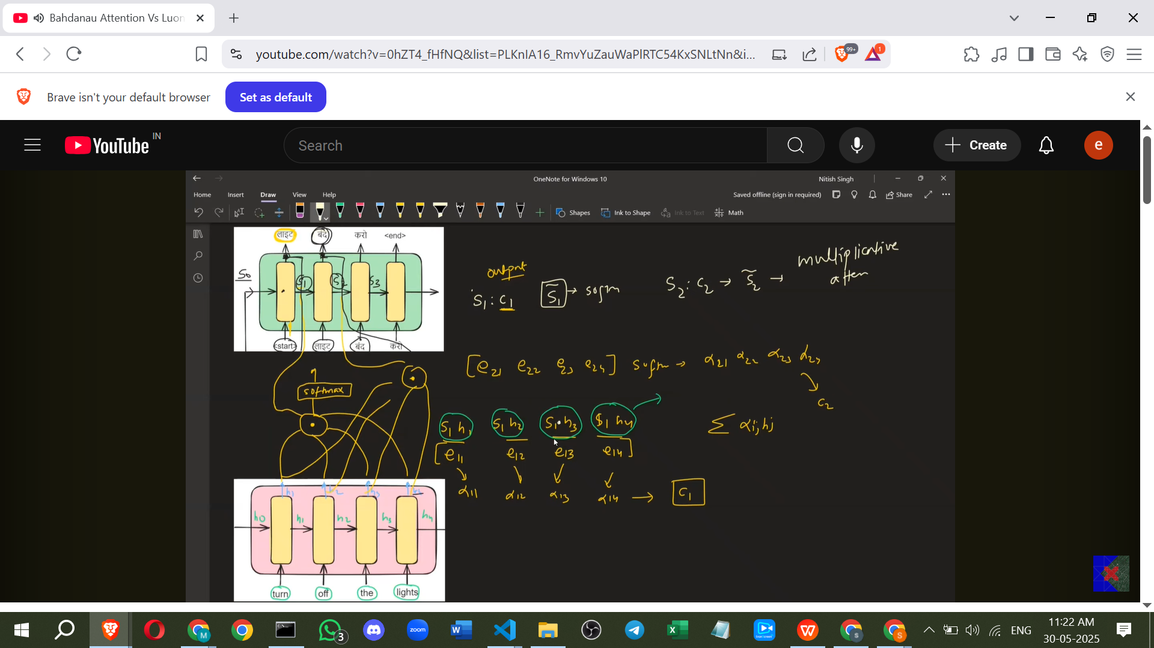

* **Benefits of Luong Attention:**
  + Experimentally proven to give better results than Bahdanau Attention.
  + Faster because using the dot product eliminates the extra parameters of the FFNN used in Bahdanau.
  + Using the current decoder state (s_i) provides a more updated context for calculating attention, leading to more dynamic translation.

**8. Importance for Transformers**

* Understanding Bahdanau and Luong attention is crucial for understanding the Self-Attention mechanism used in Transformers.
* Self-Attention, which is a core component of the Transformer architecture, draws inspiration from these two types of attention.

**Additional Points for Understanding (Not directly from sources, require independent verification):**

* **Purpose of Softmax:** Applying softmax to the alignment scores (e_ij) serves two main purposes: 1) It converts the raw scores into probabilities (or weights that sum to 1), making them directly interpretable as how much "attention" or weight each encoder hidden state should receive. 2) It ensures that the weights are non-negative.
* **Dot Product as Similarity:** The dot product between two vectors can be interpreted geometrically. A large positive dot product means the vectors point in roughly the same direction (high similarity). A small or negative dot product means they point in different directions (low similarity). In Luong attention, this is used to quantify how "aligned" or relevant an encoder state (h_j) is to the current decoder state (s_i).
* **Parameter Comparison:** Bahdanau Attention introduces a dedicated neural network with its own weights to learn the alignment function. Luong Attention, by using the dot product, avoids this extra network and its parameters, which contributes to its speed advantage. The weights involved in Luong's dot product are implicitly learned within the main network's training process.

By understanding how Bahdanau and Luong mechanisms calculate and use attention scores based on different decoder states (previous vs. current) and different alignment functions (FFNN vs. Dot Product), you gain valuable insight into the core ideas that underpin modern attention models like those in Transformers.